**EC2 TASK**

1. Launch one EC2 using Amazon Linux 2 image and add a script in user data to install Apache.

*create a new instance, apache-server

*add configuration ,security default,

*add script in additional settings, in user data option

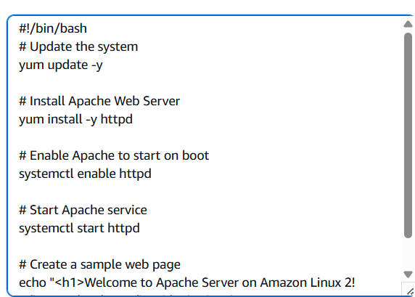

*now connect to linux machine by adding ssh -ip

*to verify – sudo systemctl status httpd

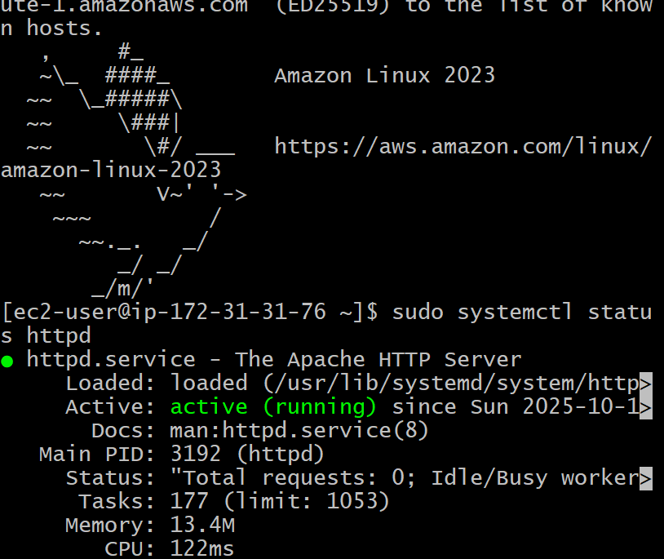

2. Launch one EC2 using Ubuntu image and add a script in user data to install Nginx.

*launch an instance in ec2 , using ami as ubuntu

*adding security rules

*enter install nginx script in additional pannel

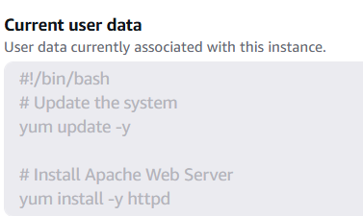

*now connect to instance using – pem key

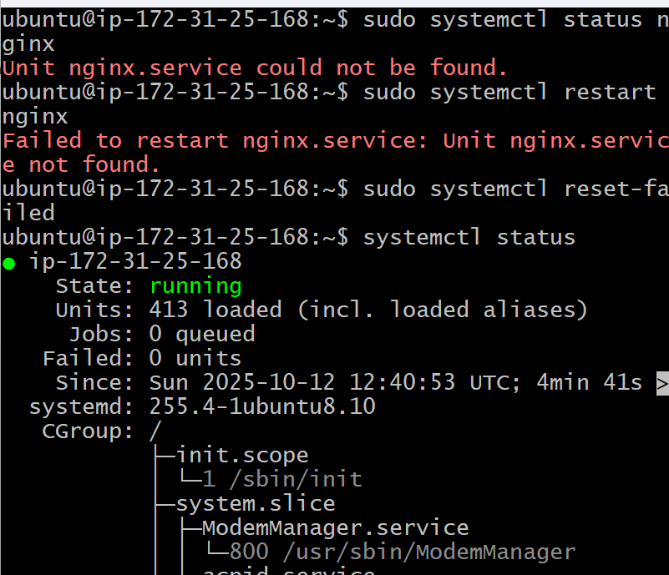

*check= sudo systemctl status

3. Launch one Windows server and install Tomcat on Windows.

*launch an instance called tomcat-server

*use windows

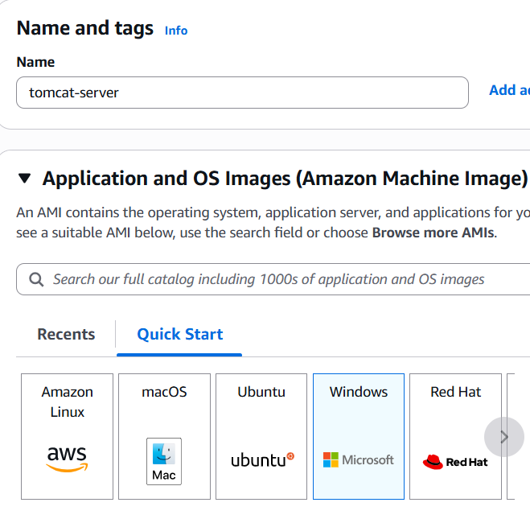

*network settings

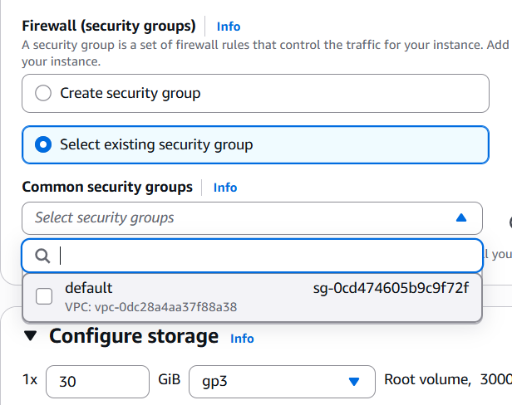

*added install tomcat script

*added pem.key file in rep endpoint

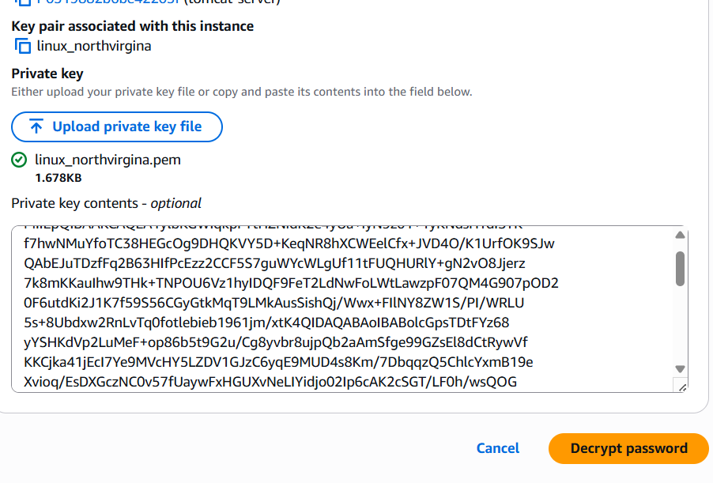

*connect using RDP

*upload pem.key

*create password , for administrator

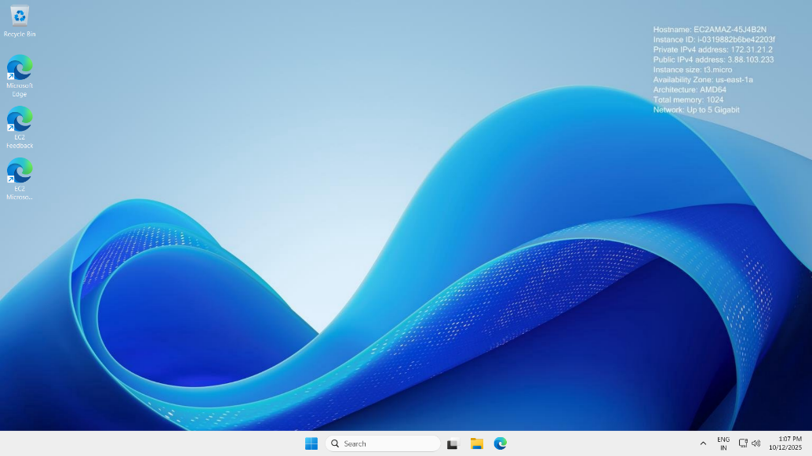

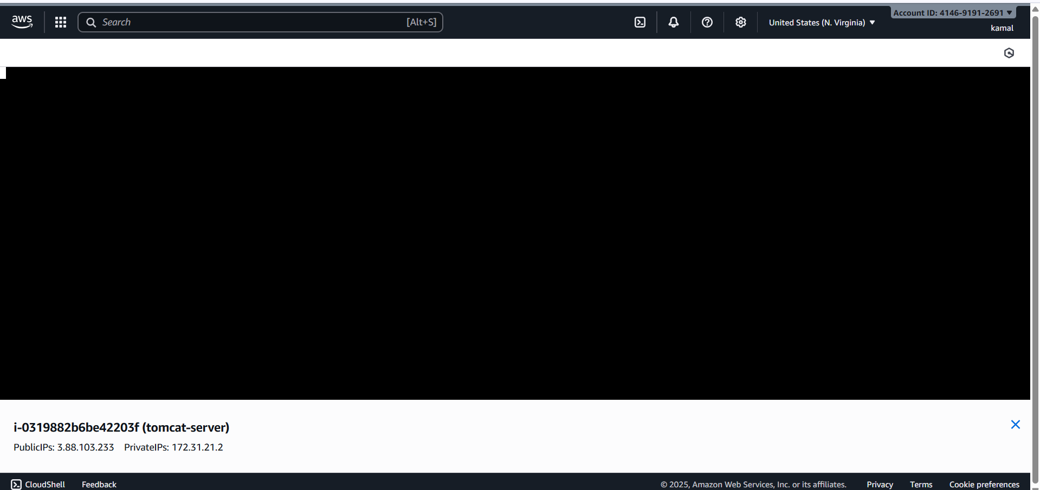

4. Take a snapshot of the instance created in Task 1.

*select the instance and go to storage coloumn

*now select the volume and

*check the actions

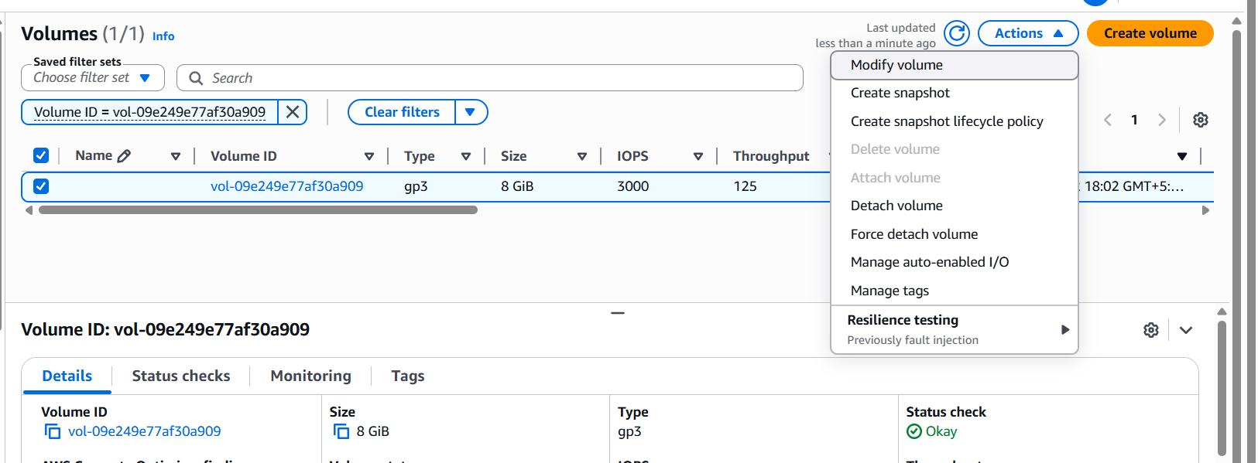

*create snapshot

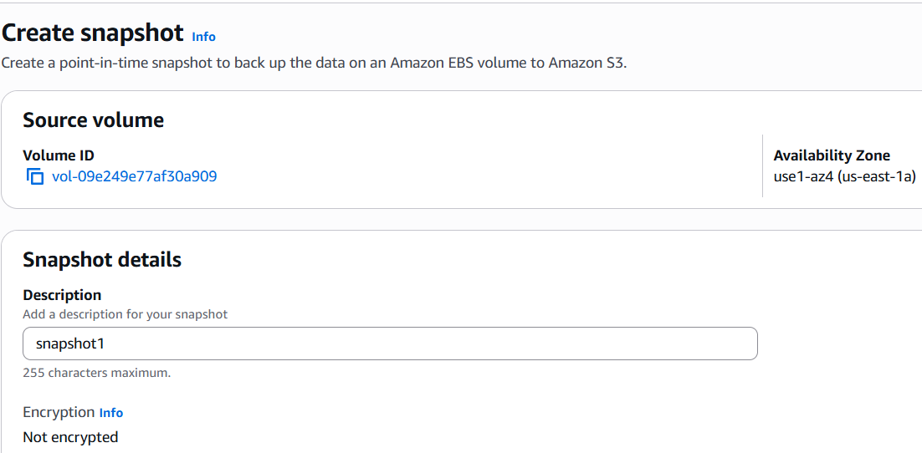

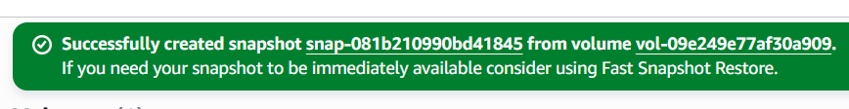

*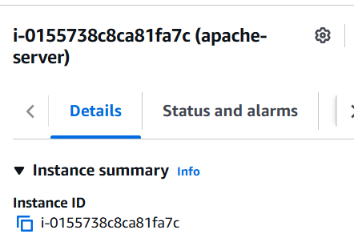

5. Assign passwordless authentication for the EC2 created in Task 2.

*ssh key-gen

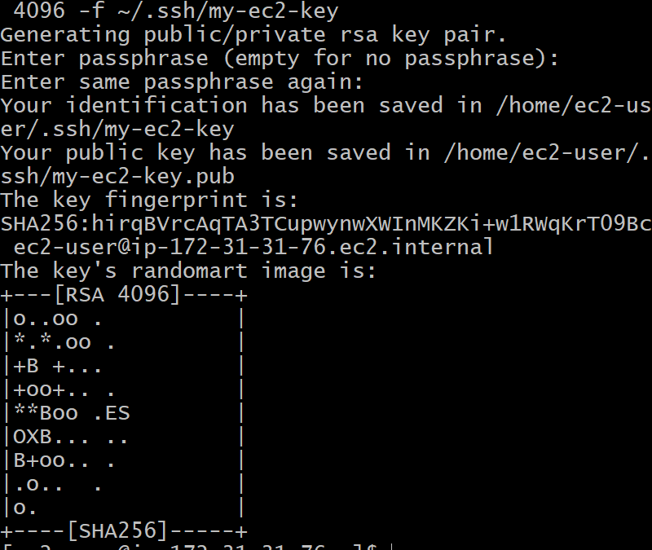

*list the keys created

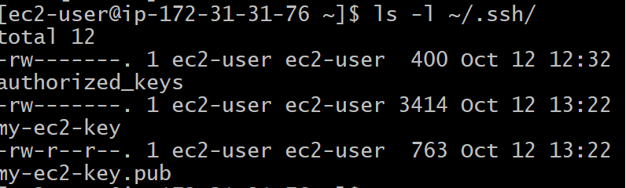

6. Launch any EC2 using the spot purchasing option.

*add spot request in additional user

*select maximum price

*request type one-time

*interruption behavious = terminate

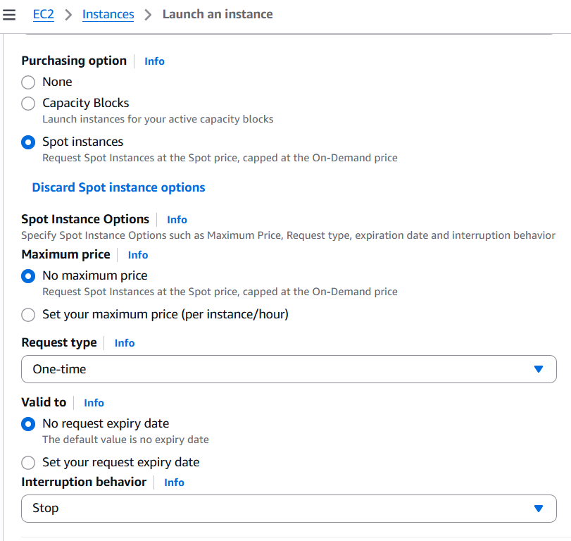

*instance launched succelsfully

7. Enable termination policy on the EC2 created in Task 2.

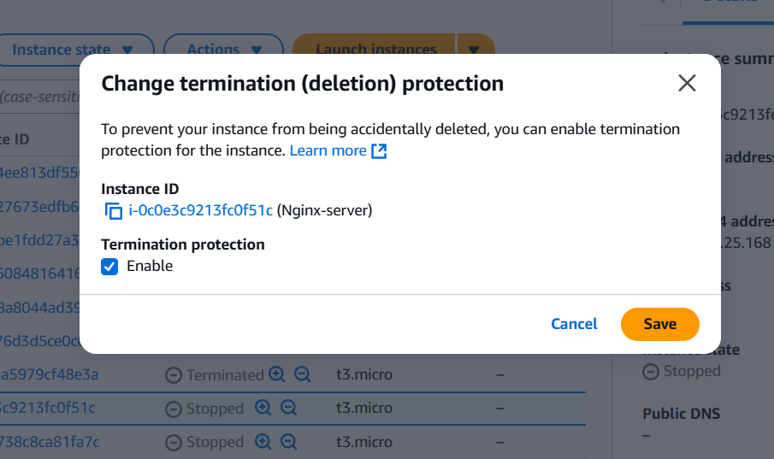

8.Launch one EC2 using AWS CLI.

*create a aws access key in GUI

*access key and password

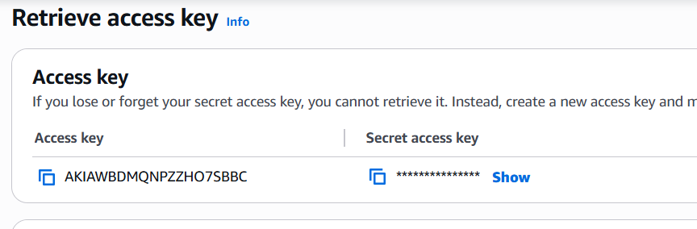

*configure cli and gui

*command = aws configure

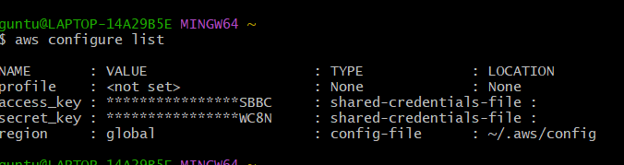

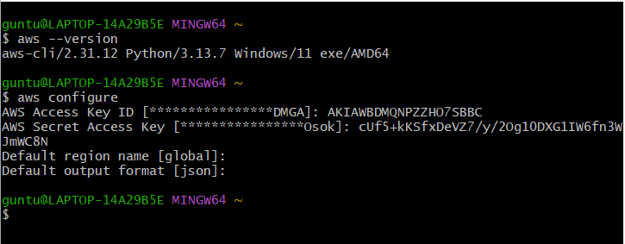

*list out the existing commands

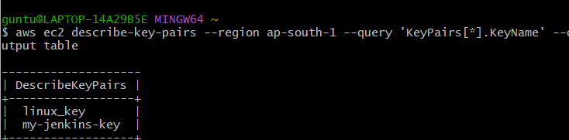

*run instance command

aws ec2 run-instances \

--region ap-south-1 \

--image-id ami-0dee22c13ea7a9a67 \

--instance-type t2.micro \

--key-name linux_key \

--count 1 \

--associate-public-ip-address

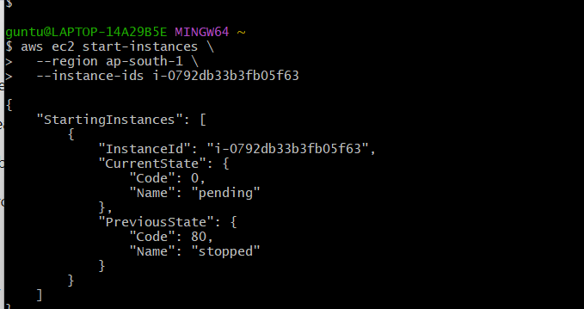

*to verify

aws ec2 describe-instances \

--region ap-south-1 \

--query "Reservations[*].Instances[*].[InstanceId,State.Name,PublicIpAddress]" \

--output table

*output

